ETHNICITY, LANGUAGE AND RELIGION OF BANGLADESH
Bangladesh is noted for the ethnic homogeneity of its population. Over 98 percent of the people are Bengalis, predominantly Bangla-speaking peoples. People speaking Arabic, Persian, and Turkic languages also have contributed to the ethnic characteristics of the region.
A member of the Indo-European family of languages, Bangla (sometimes called Bengali) is the official language of Bangladesh. Bangladeshis closely identify themselves with their national language. Bangla has a rich cultural heritage in literature, music, and poetry, and at least two Bengali poets are well known in the West: Rabindranath Tagore, a Hindu and a Nobel laureate; and Kazi Nazrul Islam, a Muslim known as the "voice of Bengali nationalism and independence." Bangla has been enriched by several regional dialects. The dialects of Sylhet, Chittagong, and Noakhali have been strongly marked by Arab-Persian influences. English, whose cultural influence seemed to have crested by the late 1980s, remained nonetheless an important language in Bangladesh.
Biharis, a group that included Urdu-speaking non-Bengali Muslim refugees from Bihar and other parts of northern India, numbered about 1 million in 1971 but had decreased to around 600,000 by the late 1980s. They once dominated the upper levels of Bengali society. Many also held jobs on the railroads and in heavy industry. As such they stood to lose from Bangladesh independence and sided with Pakistan during the 1971 war. Hundreds of thousands of Biharis were repatriated to Pakistan after the war.
Bangladesh's tribal population consisted of 897,828 persons, just over 1 percent of the total population, at the time of the 1981 census. They lived primarily in the Chittagong Hills and in the regions of Mymensingh, Sylhet, and Rajshahi. The majority of the tribal population (778,425) lived in rural settings, where many practiced shifting cultivation. Most tribal people were of SinoTibetan descent and had distinctive Mongoloid features. They differed in their social organization, marriage customs, birth and death rites, food, and other social customs from the people of the rest of the country. They spoke Tibeto-Burman languages. In the mid-1980s, the percentage distribution of tribal population by religion was Hindu 24, Buddhist 44, Christian 13, and others 19.
The four largest tribes were the Chakmas, Marmas (or Maghs), Tipperas (or Tipras), and Mros (or Moorangs). The tribes tended to intermingle and could be distinguished from one another more by differences in their dialect, dress, and customs than by tribal cohesion. Only the Chakmas and Marmas displayed formal tribal organization, although all groups contained distinct clans. By far the largest tribe, the Chakmas were of mixed origin but reflected more Bengali influence than any other tribe. Unlike the other tribes, the Chakmas and Marmas generally lived in the highland valleys. Most Chakmas were Buddhists, but some practiced Hinduism or animism.
Of Burmese ancestry, the Marmas regarded Burma as the center of their cultural life. Members of the Marma tribe disliked the more widely used term Maghs, which had come to mean pirates. Although several religions, including Islam, were represented among the Marmas, nearly all of the Marmas were Buddhists.
The Tipperas were nearly all Hindus and accounted for virtually the entire Hindu population of the Chittagong Hills. They had migrated gradually from the northern Chittagong Hills. The northern Tipperas were influenced by Bengali culture. A small southern section known as the Mrungs showed considerably less Bengali influence.
The Mros, considered the original inhabitants of the Chittagong Hills, lived on hilltops and often fortified their villages. They had no written language of their own, but some could read the Burmese and Bangla scripts. Most of them claimed to be Buddhists, but their religious practices were largely animistic.
Tribal groups in other parts of the country included Santals in Rajshahi and Dinajpur, and Khasis, Garos, and Khajons in Mymensingh and Sylhet regions. Primarily poor peasants, these people all belonged to groups in the adjoining tribal areas of India.
Language

Languages
Bengali (Bangla), the national language of Bangladesh, belongs to the Indo-Aryan group of languages and is related to Sanskrit. Like Pali, however, and various other forms of Prakrit in ancient India, Bengali originated beyond the influence of the Brahman society of the Aryans. The Pala rulers of Bengal (8th to 12th century)—who were Buddhists and whose religious language was Pali—did not inhibit the emergence of a colloquial tongue known as Gaudiya Prakrit, the language from which Bengali developed.
Bengali is the mother tongue of almost the entire population of Bangladesh. However, the indigenous minority groups have their own languages and dialects, some of which are Tibeto-Burman languages. English, an Indo-European language, is spoken in urban centres and among educated groups.
The Bengali language has two distinct styles: sadhu bhasa, the literary style, which contains many words derived from Sanskrit, and calit bhasa, the colloquial style, which is the standard medium of informal discourse, both spoken and written. Until the 1930s sadhu bhasa was used for all printed matter, but calit bhasa is now the basic form used for contemporary literature. There also are a number of dialects. Bengali contains many loanwords from Portuguese, English, Arabic, Persian, and Hindi.

What Languages Are Spoken In Bangladesh?
Rank | Category | Languages
1 | Official languages | Bangla
2 | National languages | Bangla
3 | Regional languages | Unofficial Chittagonian, Sylheti, Chakma, Rangpuri
4 | Minority languages | Assamese, Bishnupriya Manipuri, Chakma, Hajong, Tangchangya, Oraon Sadri, Khasi, Koda, Mundari, Pnar, Santali, War-Jaintia, Kurukh, Sauria Paharia, A'Tong, Chak, Chin, Asho, Bawm, Falam, Haka, Khumi, Koch, Garo, Megam, Meitei Manipuri, Mizo, Mru, Pangkhua, Rakhine/Marma, Kok Borok, Riang, Tippera and Usoi
5 | Main immigrant languages | Bihari • Burmese • Rohingya
6 | Main foreign languages | English

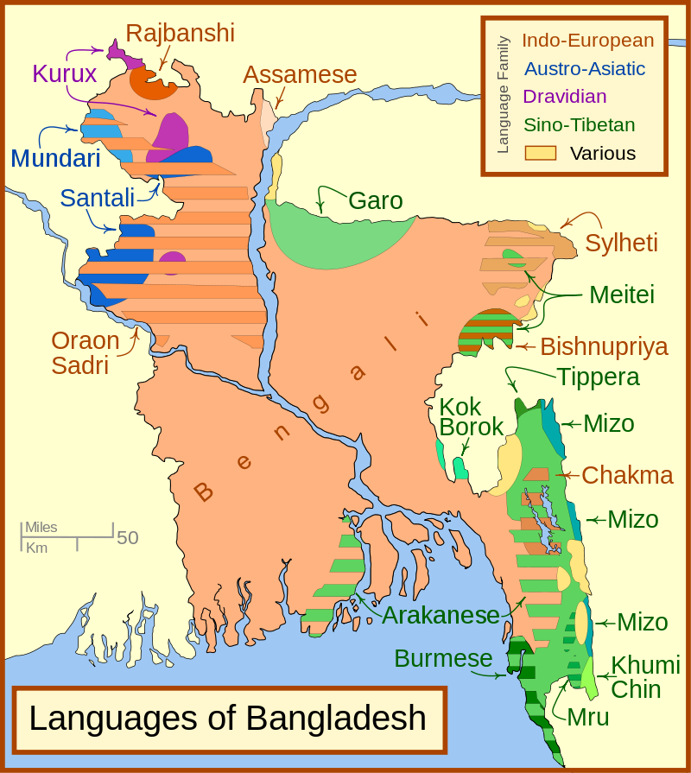

Religion
Most of the people of Bangladesh follow the religion of Islam, which was made the official religion by a 1988 constitutional amendment. The arrival of Muslims in Bengal at the beginning of the 13th century and the rapid increase in their strength and influence permanently changed the character and culture of the area. When the Muslims first arrived, Hinduism was by far the dominant religion, although there were pockets of Buddhists and a few adherents of local religions. The Hindus remained in the majority through the Mughal period (16th to 18th century).
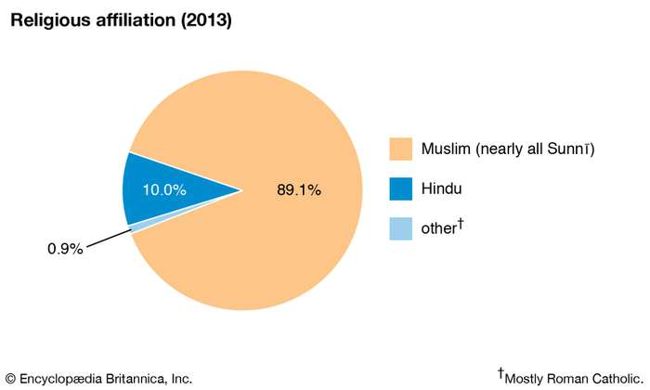
Most Muslims are Sunni, but there are a small number of Shīʿites, primarily descendants of immigrants from Iran. Hindus form a significant minority, while Roman Catholics and Buddhists constitute just a tiny fraction of the population. Of the tribes in the Chittagong Hill Tracts, the Chakma, Marma, and Mro are mostly Buddhists. Portions of the Kuki, Khomoi, and Mro communities practice local religions. While most of the Mizo are Christians, the Tripura are Hindus.

Settlement patterns
The extremely high overall population density of Bangladesh, averaging more than 2,500 persons per square mile (1,000 per square km) in the early 21st century, varies widely according to the distribution of flatland. The highest density occurs in and around Dhaka, which is also the centre of the country’s most fertile zone; the lowest population density occurs in the hills of Chittagong.

Rural settlement
The rural area throughout Bangladesh is so thickly settled that it is often difficult to distinguish any well-defined pattern of individual villages. There are, however, some noticeable features. The inundation of most of the fields during the rainy season makes it necessary to build houses on higher ground. Continuous strings of settlements along roads are common in areas south of the upper Padma River and in the floodplains of the Mahananda, Tista, Jamuna, lower Padma, and Meghna rivers. Similar settlements are found in the Chittagong Hills and in the hilly segment of the southern Sylhet region. Settlements are more scattered, however, in areas in southwestern Bangladesh along the Bay of Bengal, in the floodplains of the Old Brahmaputra, in the lower-lying areas of eastern and southern Sylhet, and in parts of Chittagong. In central and western Sylhet and in some areas of the Chittagong Hills, settlements occur in a nucleated, or clustered, pattern. With the addition of prefabricated one- or two-story structures scattered among thatched bamboo huts, the character of rural villages has changed since the mid-20th century. Supplies of electricity and safe drinking water, however, have remained inadequate in some regions.

Urban settlement
Although industrial development has prompted migration to the cities, Bangladesh is one of the least-urbanized areas in South Asia. In the 2010s about one-third of the population lived in urban areas. There are three major cities: Dhaka, Chittagong, and Khulna. Dhaka, the capital, is the largest. Chittagong, the country’s major port, is second in importance. A number of industrial areas, such as Kalurghat, Sholashahar, and Faujdar Hat, have developed around Chittagong. Khulna, in the southwest, has become a commercial and industrial centre; the opening of the port at Mongla nearby and the growth of the Daulatpur industrial area have increased its population.
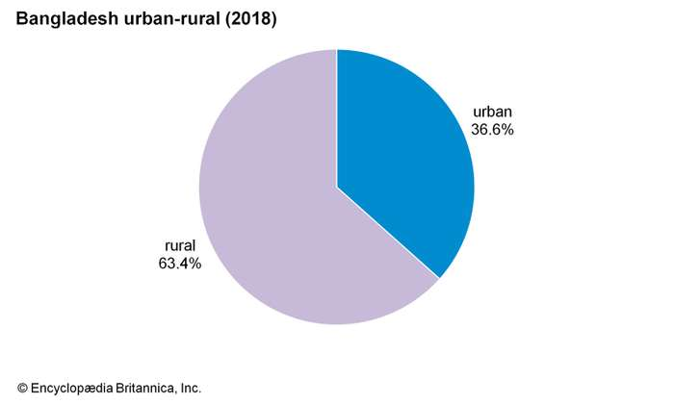

Demographic trends
In the 2010s more than one-fourth of Bangladesh’s population was under age 15. The birth rate dropped from well above the world average at the beginning of the decade to about average. Infant mortality had dropped dramatically since the late 20th century but remained high. Life expectancy was about 74 years. There has been very little immigration since the 1970s. Many Bangladeshis, however, live and work abroad—especially in India.
